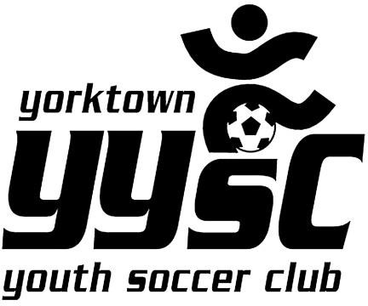LABOR DAY TOURNAMENT 2022

Business Sponsor Advertisement

Team Name/Sold by: _

Advertiser’s Name: _ _

Advertiser’s Phone

Advertiser’s Email: _ _

Charitable Donation:

A gift made by an individual or an organization to a nonprofit organization,

charity or private foundation. Charitable donations are commonly in the form of cash, but can also take the form of real estate, motor vehicles, appreciated securities, clothing

and other assets or services.

Dear Sponsor:

The Yorktown Youth Soccer Club will be hosting our Annual 2022 Labor Day Soccer Tournament. **We are asking you to support the YYSC Travel Teams by advertising with our club. Please choose one or more of the choices below:**

This year we will be offering the following: Please Circle:

# Choice 1 – Virtual Business Card Journal $100

Your business card in a “Virtual Directory” located on our website

# Choice 2 - Field Sign $250

Your Business name and contact on a sign at the field

**Choice 3– – Email Blast**

Sponsor information will be sent to all YYSC families for the amount of time purchased

Please circle one:

# $500/6 months $850 / 1 year

**Choice 4**- **Website Advertising-** Fixed Ad on Website (home page with email blast)

# $500/4 months( 6 emails) $1200/ 1 year(12 emails)

**Choice 5- Uniform Advertising:** Your Logo **or company name** will be placed on a club uniform- Due by 8/15/22

# 1 Team Rec Division $350

**Rec Division $1000**

**Choice 6- Banner Options-**

1. **4x8 Banner of fence at tournament (2 days) $500**
2. **7x6 Banner- Fixed location $1000**
3. **18x7 Banner- Fixed location $1500**

# Donation: (please circle one) $50 $75 $100 $250 $500

mail to:

YYSC

1928 Commerce Street Yorktown Heights, NY 10598

Phone (914) 214-8118 Email [YYSC@VERIZON.NET](mailto:YYSC@VERIZON.NET)